### 4.5 IIS Server

An IIS server is the type that you probably interact with the most on a daily basis - a web server.

Some usages of IIS Servers include:

* FTP - File Transfer Protocol
  + file share
  + faster than SMB, but has less functionality (only for transferring your basic files)
  + service name: **FTP Publishing Service**
* HTTP - Hypertext Transfer Protocol
  + websites
  + service name: **World Wide Web Publishing Service**
* SMTP - Simple Mail Transfer Protocol
  + relaying mail
  + service name: **SMTP Server**

Each IIS server type has their own respective services. Make sure that they are Automatic and Started if you are using them.

# IIS Manager

The IIS Manager is the graphical user interface of IIS. Here, you can add FTP sites or websites, manage site logs, configure content and security settings, and more.

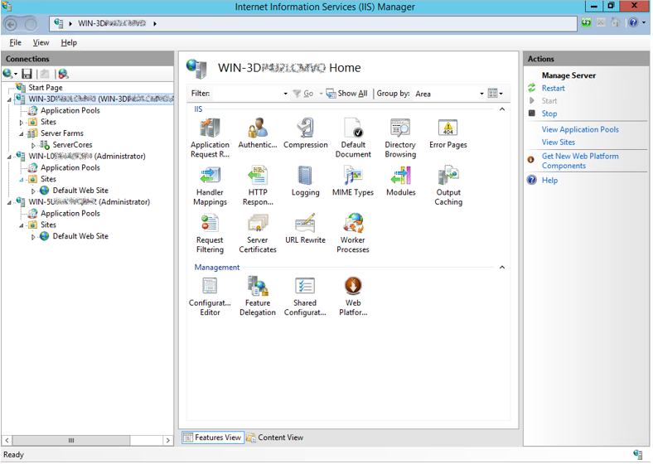

# IIS Manager 6.0

A less fancy graphical user interface that you use for configuring SMTP settings. Yes, there are two IIS managers, and yes, the other one doesn’t have SMTP. I don’t really know why - that research is for another time.

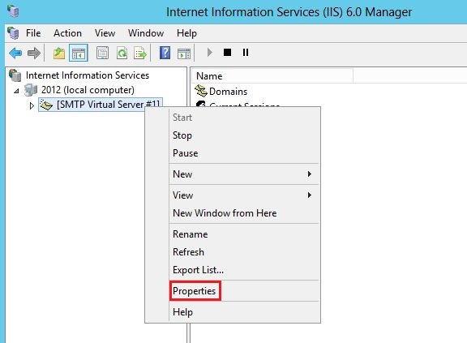

# Setup and Security

The best way to learn more is by making your own web server and exploring all the different paths/options on your own. The process isn’t all too complicated.

I will, however, not leave you without a hint on the security of these types of servers.

Security:

* Make sure that only authorized users can access. If the site is meant to be anonymously accessible, make sure that anonymous access it allowed
* Users should not have the ability to directory browse - that it, they should not be able to view your site like Windows Explorer, where they can see other files. They should only be able to access files if they give a specific path
* Enable logging
* Open your ports for your service

You can find more information regarding security with the CIS Benchmarks for IIS servers: <https://www.cisecurity.org/benchmark/microsoft_iis/>